Statistics for Gadgetzz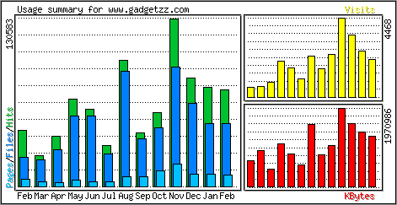
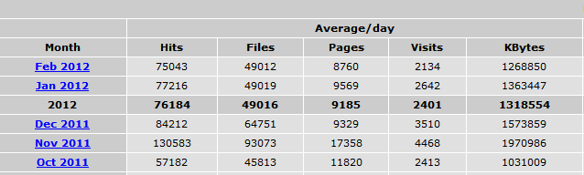

We have on average around 1000 to 7000 unique ip visitors per day, with around 90000+ hits per day.
We use AWStats together with Wordpress.com statistics to measure this.

The site is shared a lot on social networks like Facebook, Twitter, Stumbleupon and Reddit, and therefore not only has a very high reach but also sometimes our visitors spike by a lot.
Most visitors are direct visitors, but we get a lot from Google and other search engines too.
This is for January 2013.
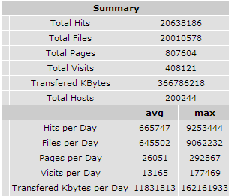

We have mostly visitors from the United States, but many from Europe and some from Asia as well.
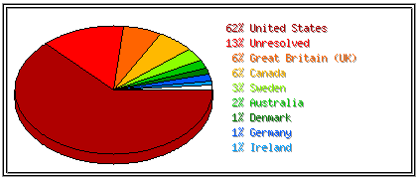

Here you can see live statistics. Keep in mind, this is just to see how many are currently on the site, it does not represent all visitors.
http://www.revolvermaps.com/?target=enlarge&i=1xknucc5sd1&color=a00000&m=1

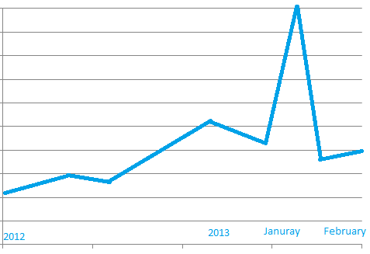
This is just to give an overview of our growth rate.

Here are our Alexa stats.
http://www.alexa.com/siteinfo/gadgetzz.com#

Social:
This is our facebook page, and here is our twitter.

For any questions, just email me at: Johny@gadgetzz.com

